Assignment 1 - Virtualization and Containerization

Name: Manish Yendeti

Id: 801429980

Course: Cloud Computing for Data Analysis (ITCS 6190/8190, Fall 2025)

1. Commands Used

# Build and start the stack

docker compose up --build

# Alternative one-command run with Makefile

make all

# Stop and remove containers + volumes

docker compose down -v

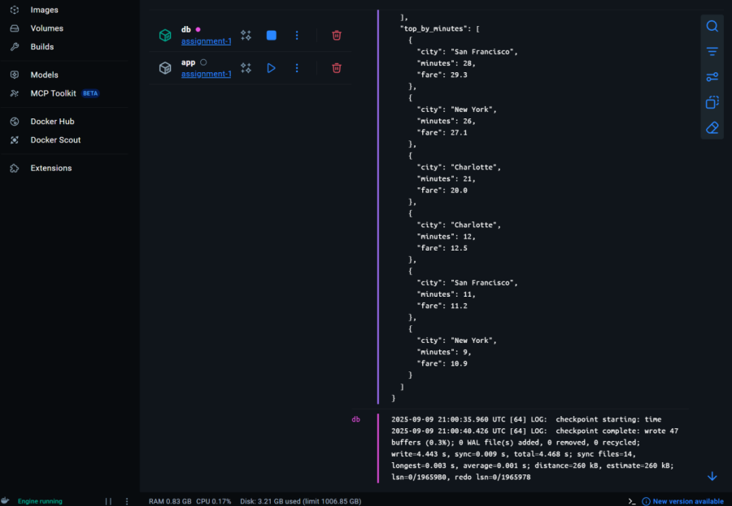

2. Output from Stdout (sunmmary.JSON)

=== Summary ===

app-1 | {

app-1 | "total_trips": 6,

app-1 | "avg_fare_by_city": [

app-1 | {

app-1 | "city": "New York",

app-1 | "avg_fare": 19.0

app-1 | },

app-1 | {

app-1 | "city": "San Francisco",

app-1 | "avg_fare": 20.25

app-1 | },

app-1 | {

app-1 | "city": "Charlotte",

app-1 | "avg_fare": 16.25

app-1 | }

app-1 | ],

app-1 | "top_by_minutes": [

app-1 | {

app-1 | "city": "San Francisco",

app-1 | "minutes": 28,

app-1 | "fare": 29.3

app-1 | },

app-1 | {

app-1 | "city": "New York",

app-1 | "minutes": 26,

app-1 | "fare": 27.1

app-1 | },

app-1 | {

app-1 | "city": "Charlotte",

app-1 | "minutes": 21,

app-1 | "fare": 20.0

app-1 | },

app-1 | {

app-1 | "city": "Charlotte",

app-1 | "minutes": 12,

app-1 | "fare": 12.5

app-1 | },

app-1 | {

app-1 | "city": "San Francisco",

app-1 | "minutes": 11,

app-1 | "fare": 11.2

app-1 | },

app-1 | {

app-1 | "city": "New York",

app-1 | "minutes": 9,

app-1 | "fare": 10.9

app-1 | }

app-1 | ]

app-1 | }

3. This same JSON was also written to out/summary.json on the host machine.

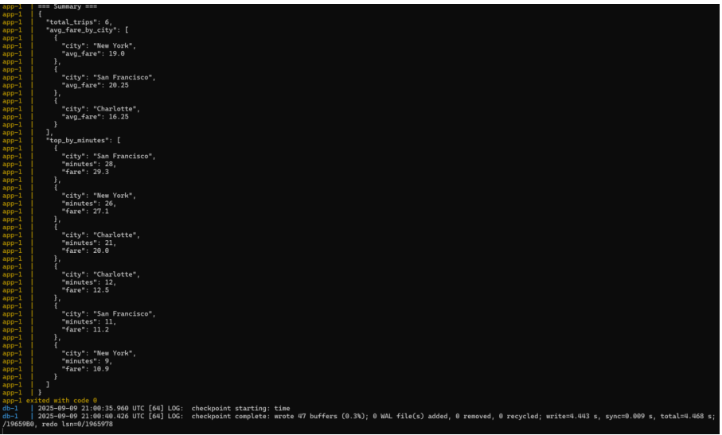

4. Reflection

This assignment taught me how to use Docker Compose to run multiple services at once. I learned how to set up PostgreSQL with some initial data and connect it to a Python app using environment variables. I also got hands-on experience writing SQL queries and dealing with database connection retries. The biggest takeaway was learning how to create workflows that can be run with just one command, making the process faster and more consistent. In the future, I would add larger datasets and improve the Python app to calculate more detailed statistics.